Multispectral Data Extraction in QGIS

Taylor Nelsen

March 20, 2019

*This standard operating procedure (SOP) was written based on QGIS Version 3.4-Madeira (Long Term Release). To download QGIS visit:* [*https://qgis.org/en/site/forusers/download.html*](https://qgis.org/en/site/forusers/download.html)

# Introduction

This SOP outlines methods to extract quantitative data from areas of interest in multispectral images. The “Low Throughput Data” section outlines how to manually create a shapefile and extract multispectral data based on that shapefile. This method needs to be understood in order to use the “High Throughput Data” methods. The low throughput data method is best used when there are few plots, they are of irregular areas, and/or they are not regularly distributed. The “High Throughput Data” section outlines a more automated process for shapefile creation and multispectral data extraction. It is best used when there are large numbers of uniform plots (uniform in size, shape, and distribution). Part 0 includes steps that are common to both methods.

# Part 0: Setup

1. Open QGIS Desktop 3.4
2. Create a new project: “Project” > “New”
3. Name and save your project: “Project” > “Save As…”
4. Add a clearly captured raster image (most commonly .tif format) of your trial or area of interest (see Figure 1): “Layer” > “Add Layer” > “Add Raster Layer…”

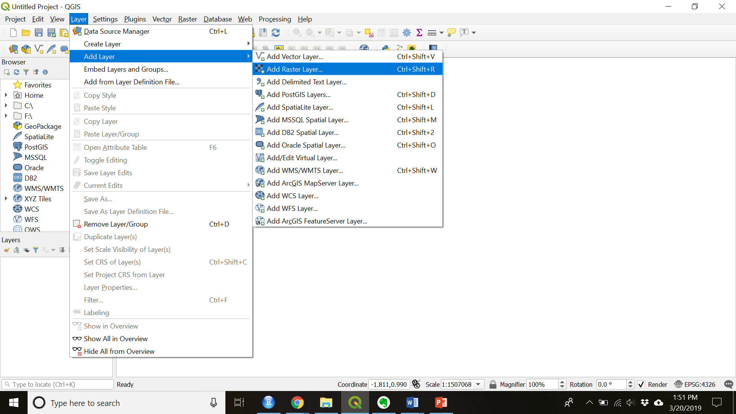

Figure 1. Add a raster layer

5. Navigate to and choose your image file.

# Part I: Low Throughput Data Method

## Create the shapefile

1. Create a new shapefile layer: “Layer” > “Create Layer” > “New Shapefile Layer…”
2. Set the properties of your shapefile:
   1. Name and save your file in folder on your computer
   2. Select “Polygon” for the geometry type

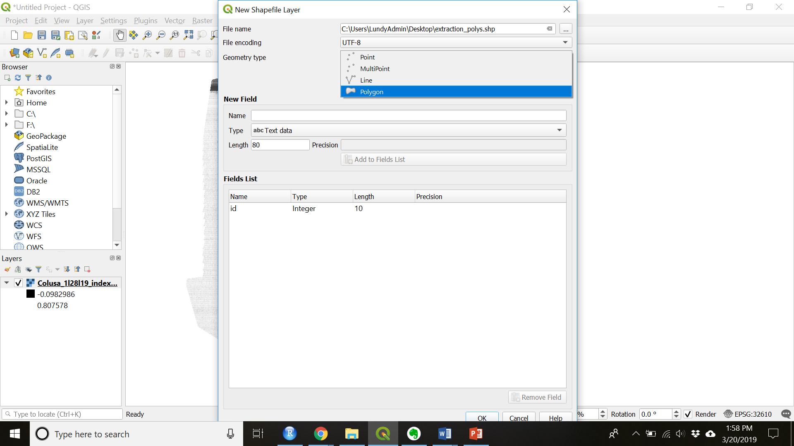

* 1. Set the coordinate system to match your multispectral image (see Figures 3 & 4)

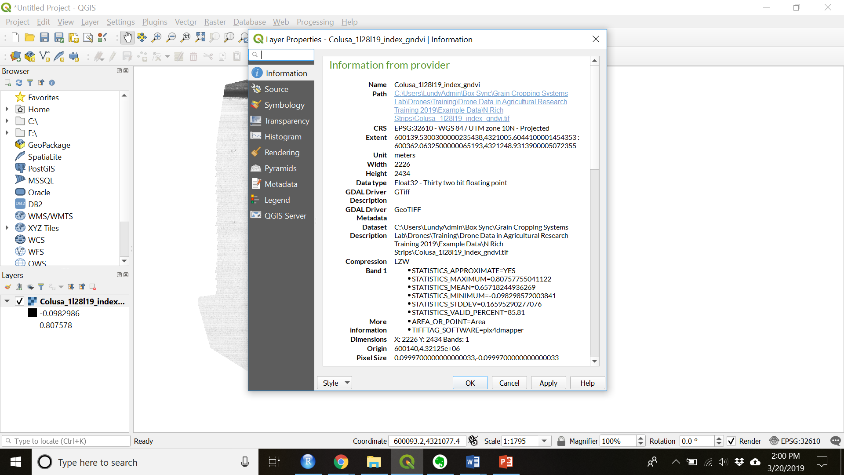

Figure 2. In the Layers panel, right click your multispectral layer and add choose "Properties" to see the CRS

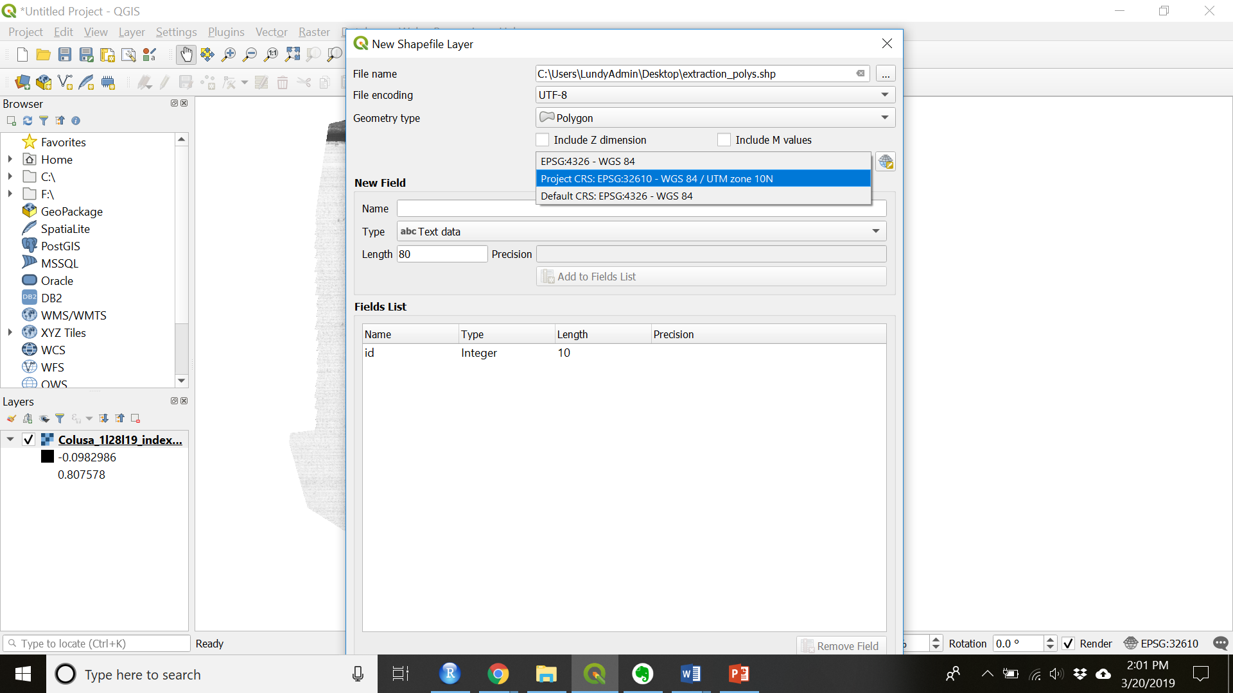

Figure 3. Choose the CRS that matches your GeoTIFF layer (WGS 84/UTM zone 10N for most Northern California M100 flights)

1. Click “OK”
2. Edit the shapefile:
   1. Make sure the shapefile you created is highlighted in the layers panel.
   2. Toggle editing on by right clicking then selecting the yellow pencil (see Figure 5)

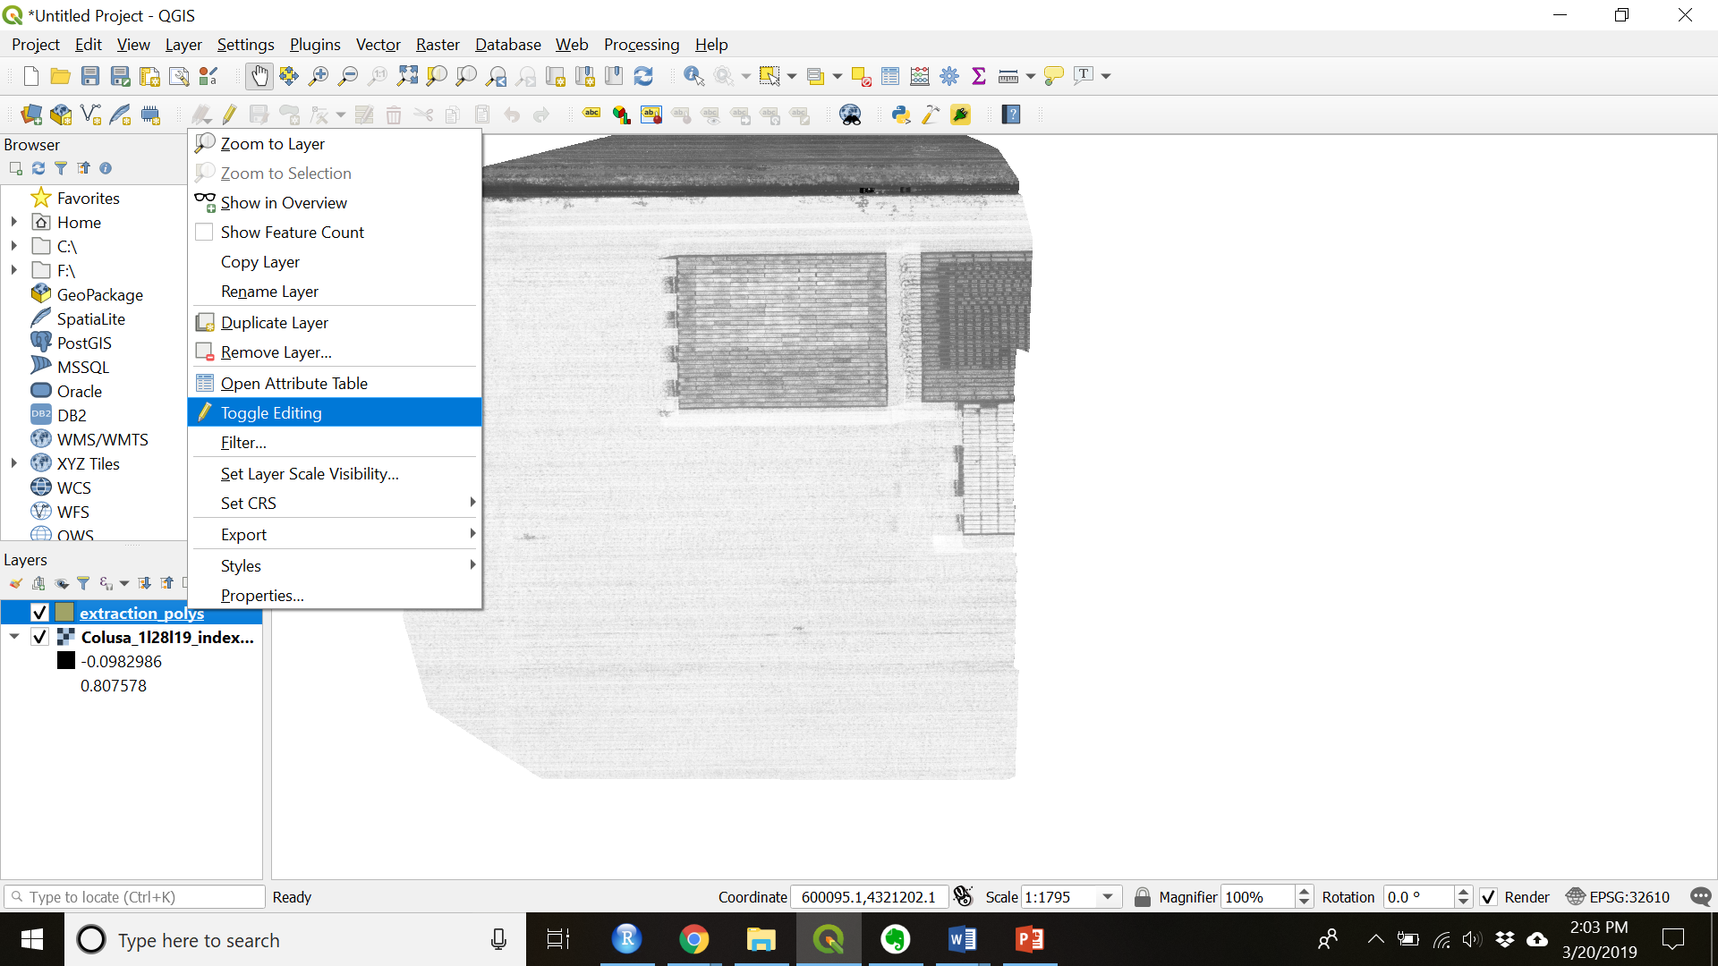

Figure 4. Toggle editing on in order to edit the blank shapefile you created

* 1. Add a feature by clicking the “Add Polygon Feature” button (see Figure 6)

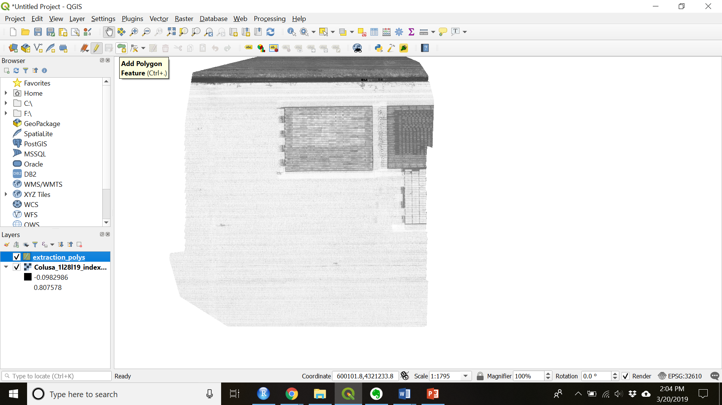

Figure 5. Add Feature to a shapefile

* 1. Using your courser click draw the outline of your area of interest. Each left click creates a point and a right click closes the polygon.
  2. Set the ID of each point as a consecutive integer.
  3. Repeat for as many features as you desire for that image.

1. End your edit session by clicking the “Toggle editing” button again.
2. Save your edits when prompted.
3. Add plot level metadata into the attribute table.
   1. Toggle editing on for the shapefile you just created
   2. Open the attribute table by right clicking the highlighted shapefile layer and choosing “Open Attribute Table” (see Figure 6).

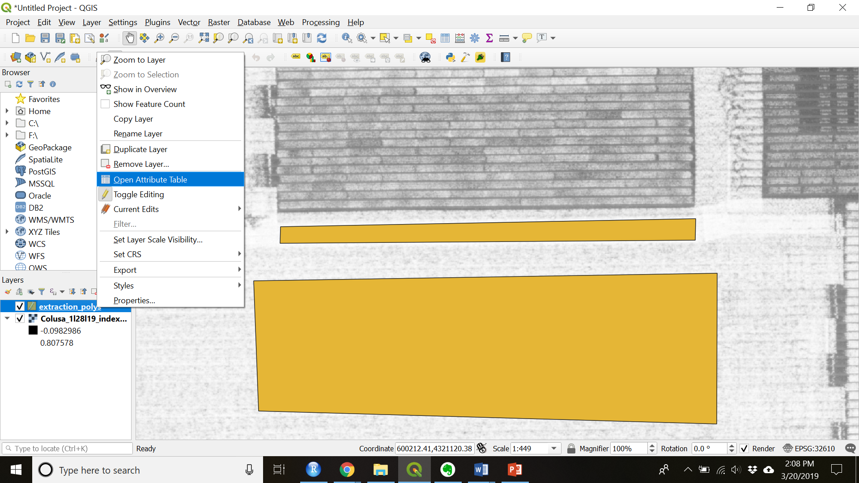

Figure 6. Open the attribute table

* 1. Ctrl + W to create a new field
  2. Name the new field appropriately and populate with metadata (see Figure 7)
     1. Make sure the “Type” and “Length” fields are filled out appropriately

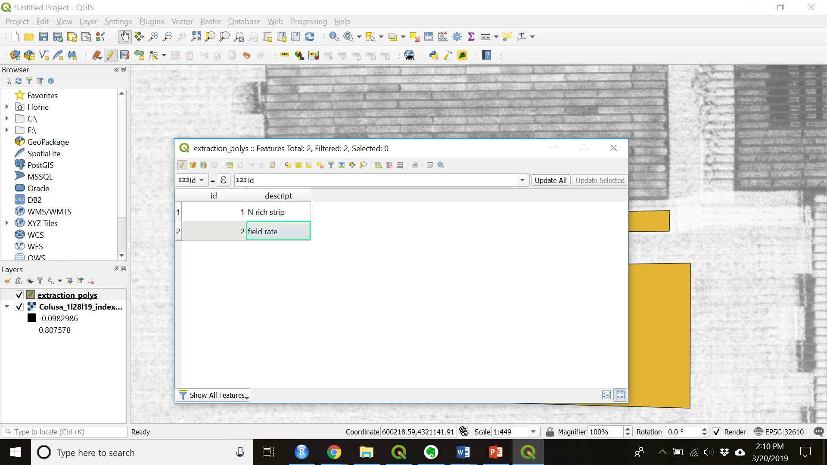

Figure 7. Populate metadata

## Zonal Statistics

1. If the processing toolbar is not already open, open it: “View” > “Panels” > “Processing Toolbox” (see Figure 8)

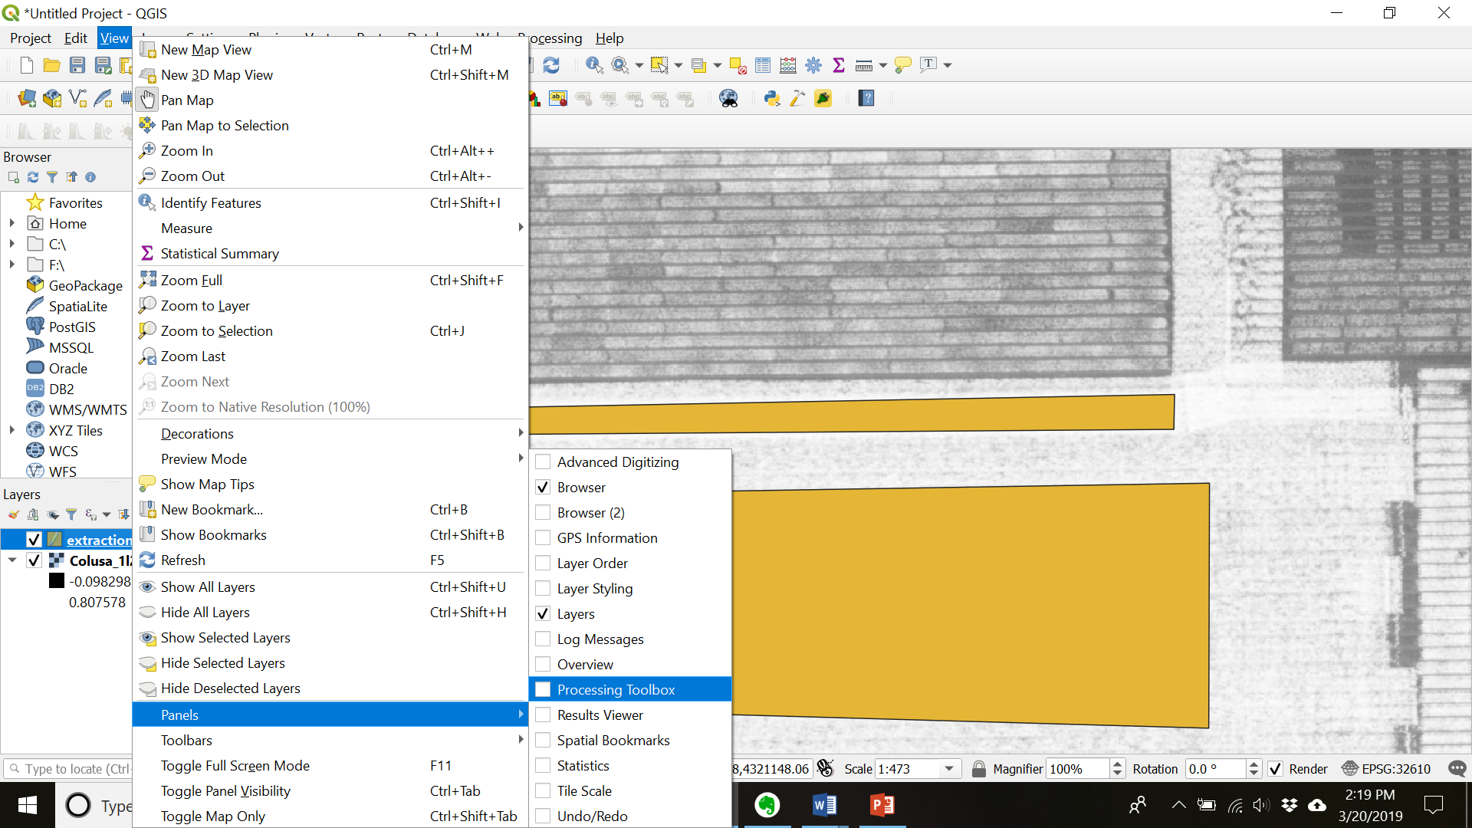

1. Find “Zonal Statistics” under “Raster Analysis” or by typing it into the search bar
2. Double click “Zonal Statistics” to open it and then fill in and run (see Figure 8).
3. Choose the raster layers band you wish to extract.
4. Choose the shapefile layer that overlays it.
5. Set the pre-fix to the band you are extracting (in order to keep track of your data)
6. Check whichever boxes of statistics you want to calculate.
7. Click “Run” to run the algorithm

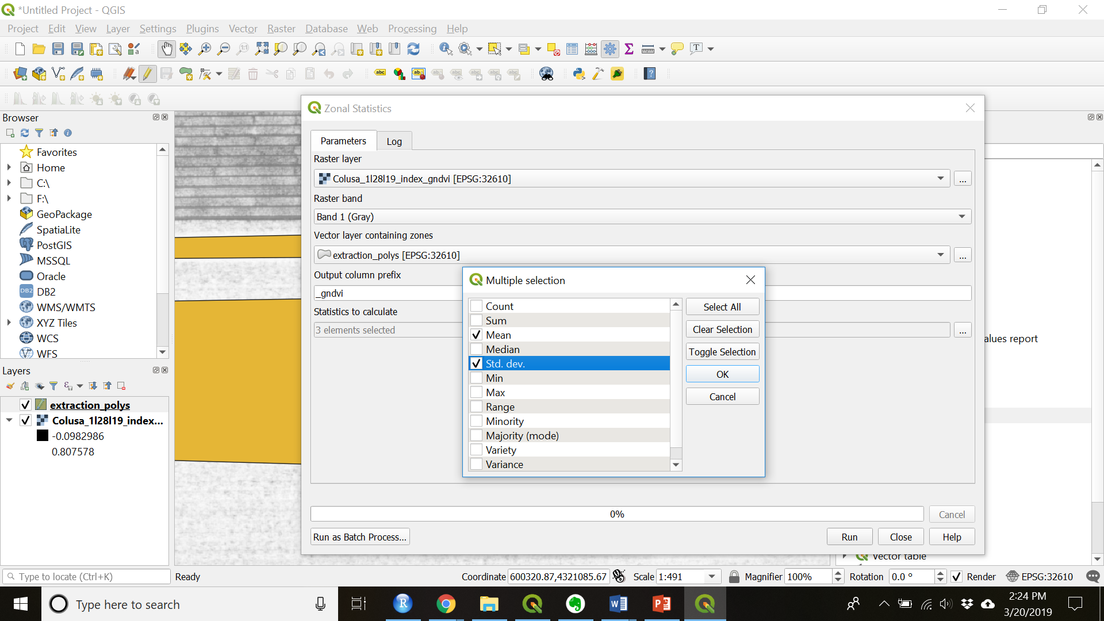

Figure 8. Setup Zonal Statistics

1. Close the Zonal Statistics window.
2. Look at the values you extracted by right clicking on your shapefile layer and navigating to “Open Attribute Table”.
3. You attribute table should contain values for each of the polygons you created and each statistic you checked in the Zonal Statistics window (see Figure 9).

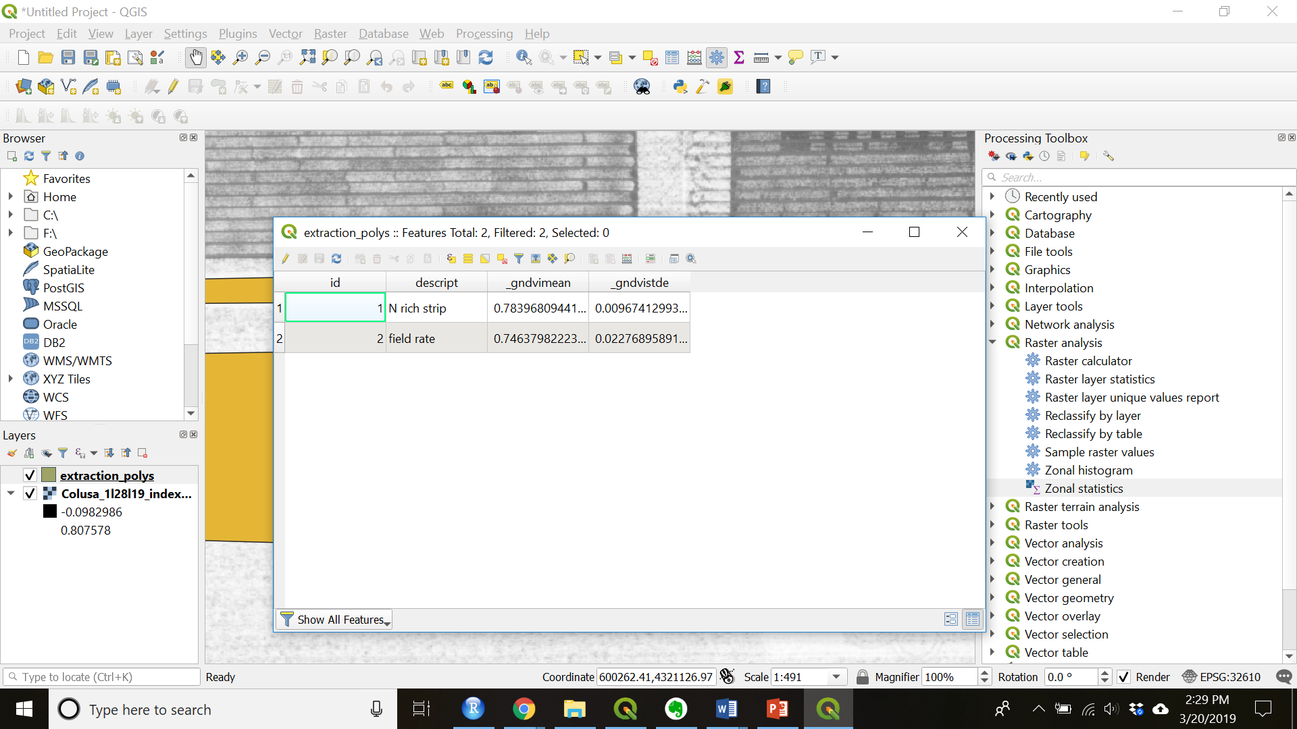

Figure 9. Check attribute table

1. The make sure you have toggled editing off and saved the shapefile.
2. Export the extracted data as a csv file
   1. Right click the highlighted shapefile
   2. Navigate to “Export” > “Save Feature As…”
   3. Change the Format to “Comma Separate Value [CSV]”
   4. Name and save the file in a folder on your computer
   5. Check that the CRS is correct
   6. All other defaults are fine to leave
   7. Press “OK” when everything is set to output and save the CSV
3. Close QGIS.

# Part II: High Throughput Data Method

## Create the shapefile

1. Check the projection of your shapefile, if it is not in latitude and longitude (EPSG: 4326) then reproject it so that it is in latitude and longitude.
   1. Make sure the raster layer is highlighted and then navigate to “Raster” > “Projections” > “Warp (Reproject)”
   2. Change the “Target CRS” to EPSG:4326 – WGS 84 (See Figure 10)

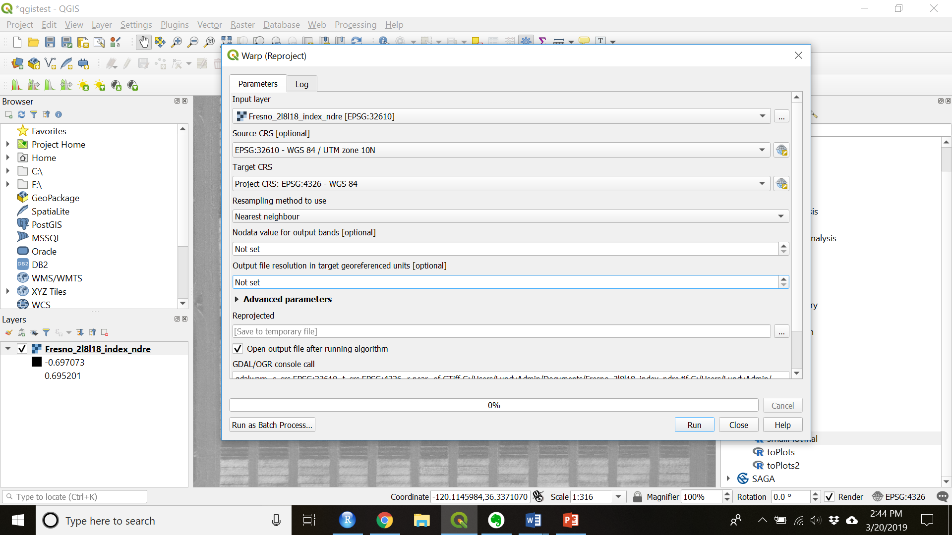

Figure 10. Reproject the raster image if needed

* 1. Click “Run” to reproject the image
  2. Close the processing window when it is done running

1. Create a shapefile to set the origin points of your trial. This is used to calculate the angle the field is at the distance the plots are from each other.
   1. Create a new layer by choosing: “Layer” > “Create New Layer” > “New Shapefile Layer…”
   2. Name and save the file to a folder on your computer
   3. Choose “Point” as the geometry
   4. Make sure the CRS is ESPG: 4326 – WGS 84
   5. Click “OK” to create the blank shapefile
2. Set the origin points.
   1. Toggle editing on the shapefile just created.
   2. Choose the “Add Point Feature” tool (see Figure 11)

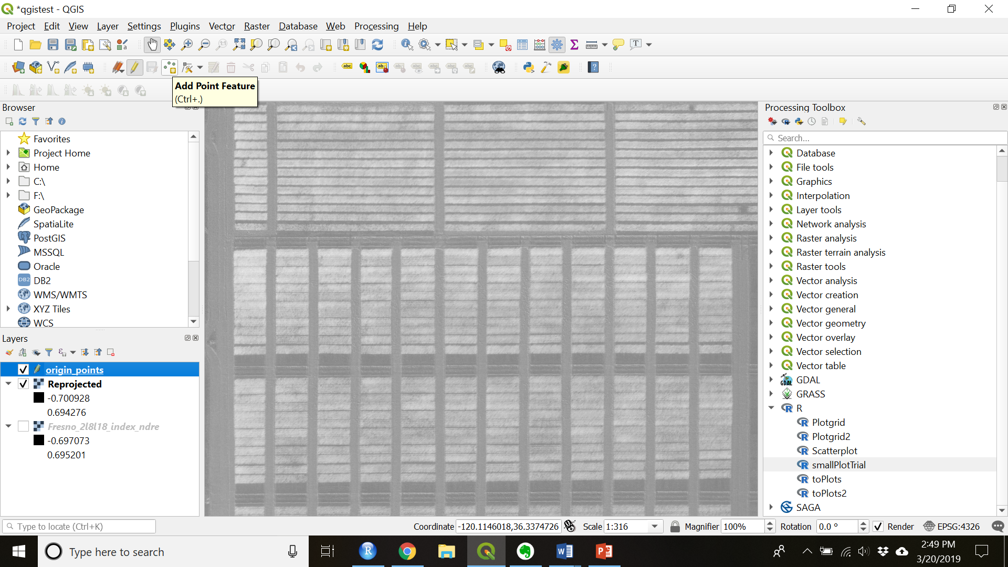

Figure 11. Add point feature

* 1. Add 3 points as follows: plot 101 (the bottom left corner of your trial) should have id = 1, the bottom right corner should have id = 2, the top left corner should have id = 3
     1. Do not include fill rows or data you do not want to extract
  2. Toggle editing off to save

1. Check that the “Processing R” plugin is installed
   1. Navigate to: “Plugins” > “Manage and Install Plugins…”
   2. Finds “Processing R Provider” by scrolling or searching
   3. Click the plugin and press “Install plugin” if the plugin is not already installed
2. The first time you do this, save the “smallPlotTrial.rsx” file in your corresponding directory:

C:\Users\UserName\AppData\Roaming\QGIS\QGIS3\profiles\default\python\plugins\processing_r\builtin_scripts

1. Make sure you have the geosphere, rgdal, raster, and rgeos packages installed in R.
   1. Open R Studio
   2. Type the following into the console: install.packages(“geosphere”)
   3. Press Enter
   4. Type the following into the console: install.packages(“raster”)
   5. Press Enter
   6. Type the following into the console: install.packages(“rgdal”)
   7. Press Enter
   8. Type the following into the console: install.packages(“rgeos”)
   9. Press Enter
2. Restart QGIS to load new script and plugin
3. In the Processing Toolbox search “smallPlotTrial” and double click it (see Figure 12)

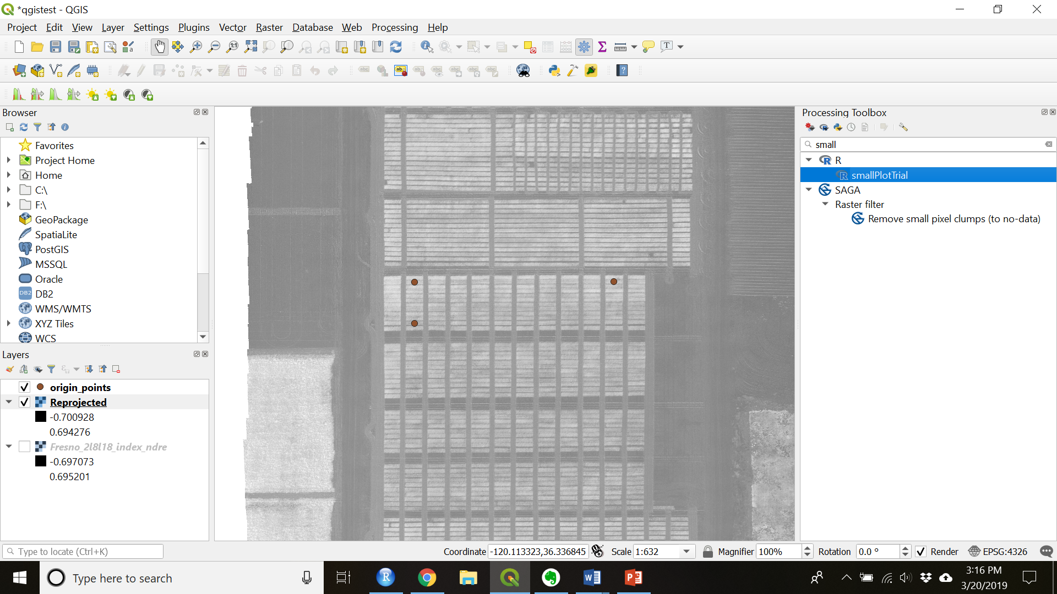

Figure 12. Navigate to smallPlotTrial

1. Set the Origin to the origin point shapefile
2. Set the correct number of rows and ranges (the default for both is 10)

*A row is defined as where the planter drives down while a range is perpendicular to the row.*

1. Click “Run”
2. Close the window when the algorithm is finished processing.
3. Save the shapefile by right clicking the Output layer that was created then “Export” > “Save Feature As…” (See Figure 13)

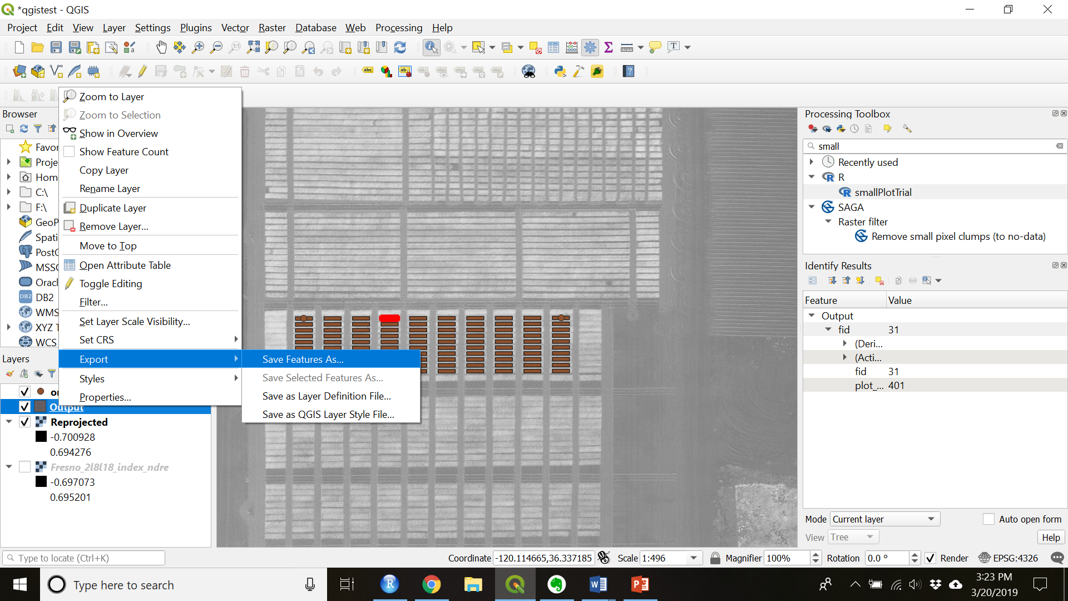

Figure 13. Save Output shapefile

1. Fill out the file name and folder location. Check to make sure the CRS is correct.

## Adjust the Shapefile

*In some cases the shapefile will need to be adjusted to make sure that it is accurately within all the plots.*

1. Toggle editing on for the shapefile.
2. Make sure the shapefile is highlighted.
3. Select all (or the subset that you wish to adjust) by choosing the “Select Features by area of single click” (see Figure 14) and drawing a rectangle around the features you want to adjust.

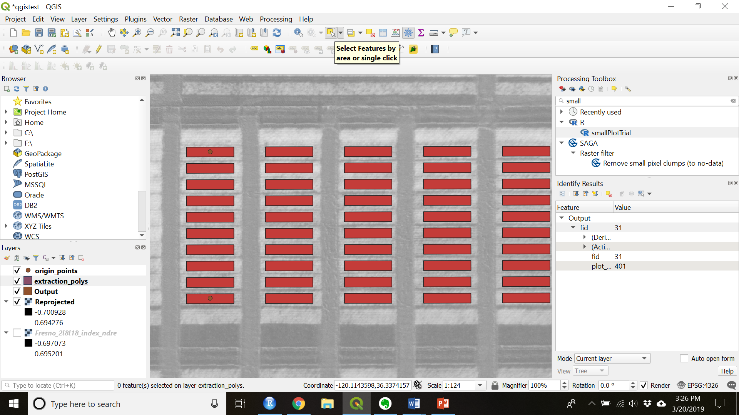

Figure 14. Select features tool

1. Make sure the “Advanced Digitizing Toolbar” is visable.
   1. If it is not navigate to “View” > “Toolbars” and check “Advanced Digitizing Toolbar”
2. Move or rotate using the appropriate tools (see Figure 9 and 10).

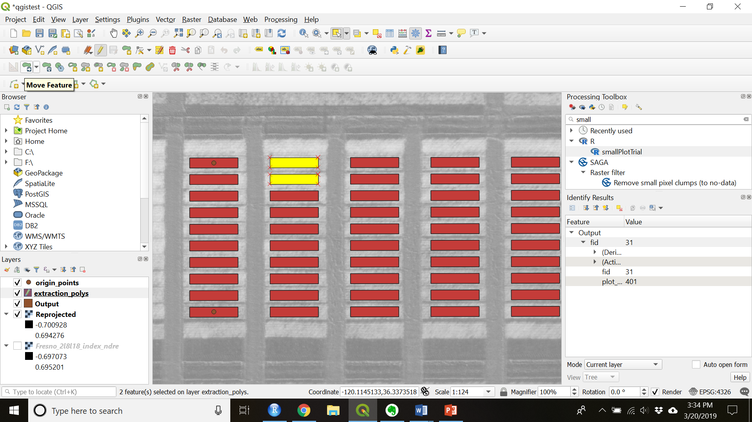

Figure 15. Move Features(s)

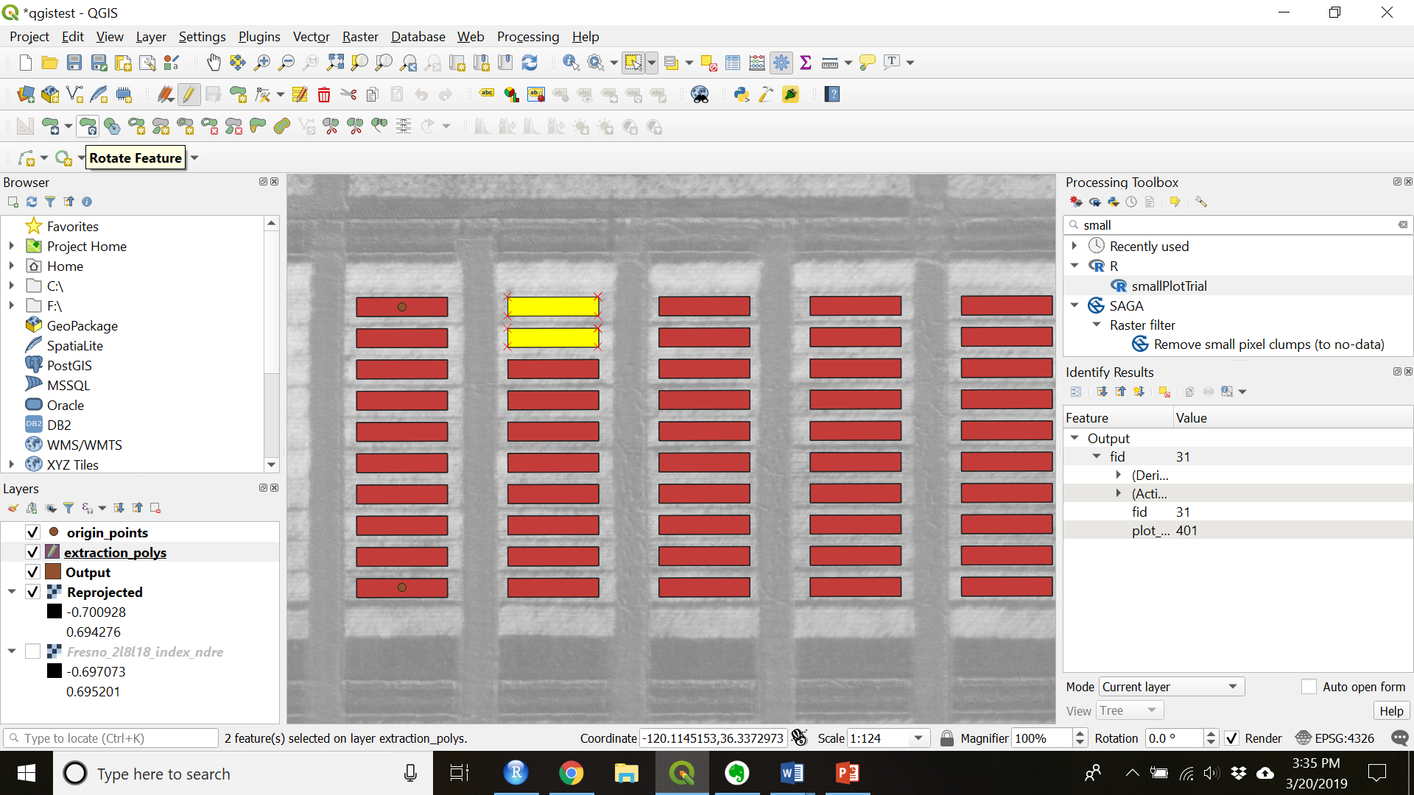

Figure 16. Rotate Features(s)

1. Toggle editing off to save.

## Zonal Statistics

*You can use the Zonal Statistics method under Part I but this method allows you to add multiple bands to one shapefile.*

1. Add the all the multispectral bands for a single date into QGIS.
2. Navigate to and open the Zonal Statistics window.
3. Choose “Run as Batch Process..” in bottom left corner
4. Select the layers that are the bands you want to extract (see Figure 17).

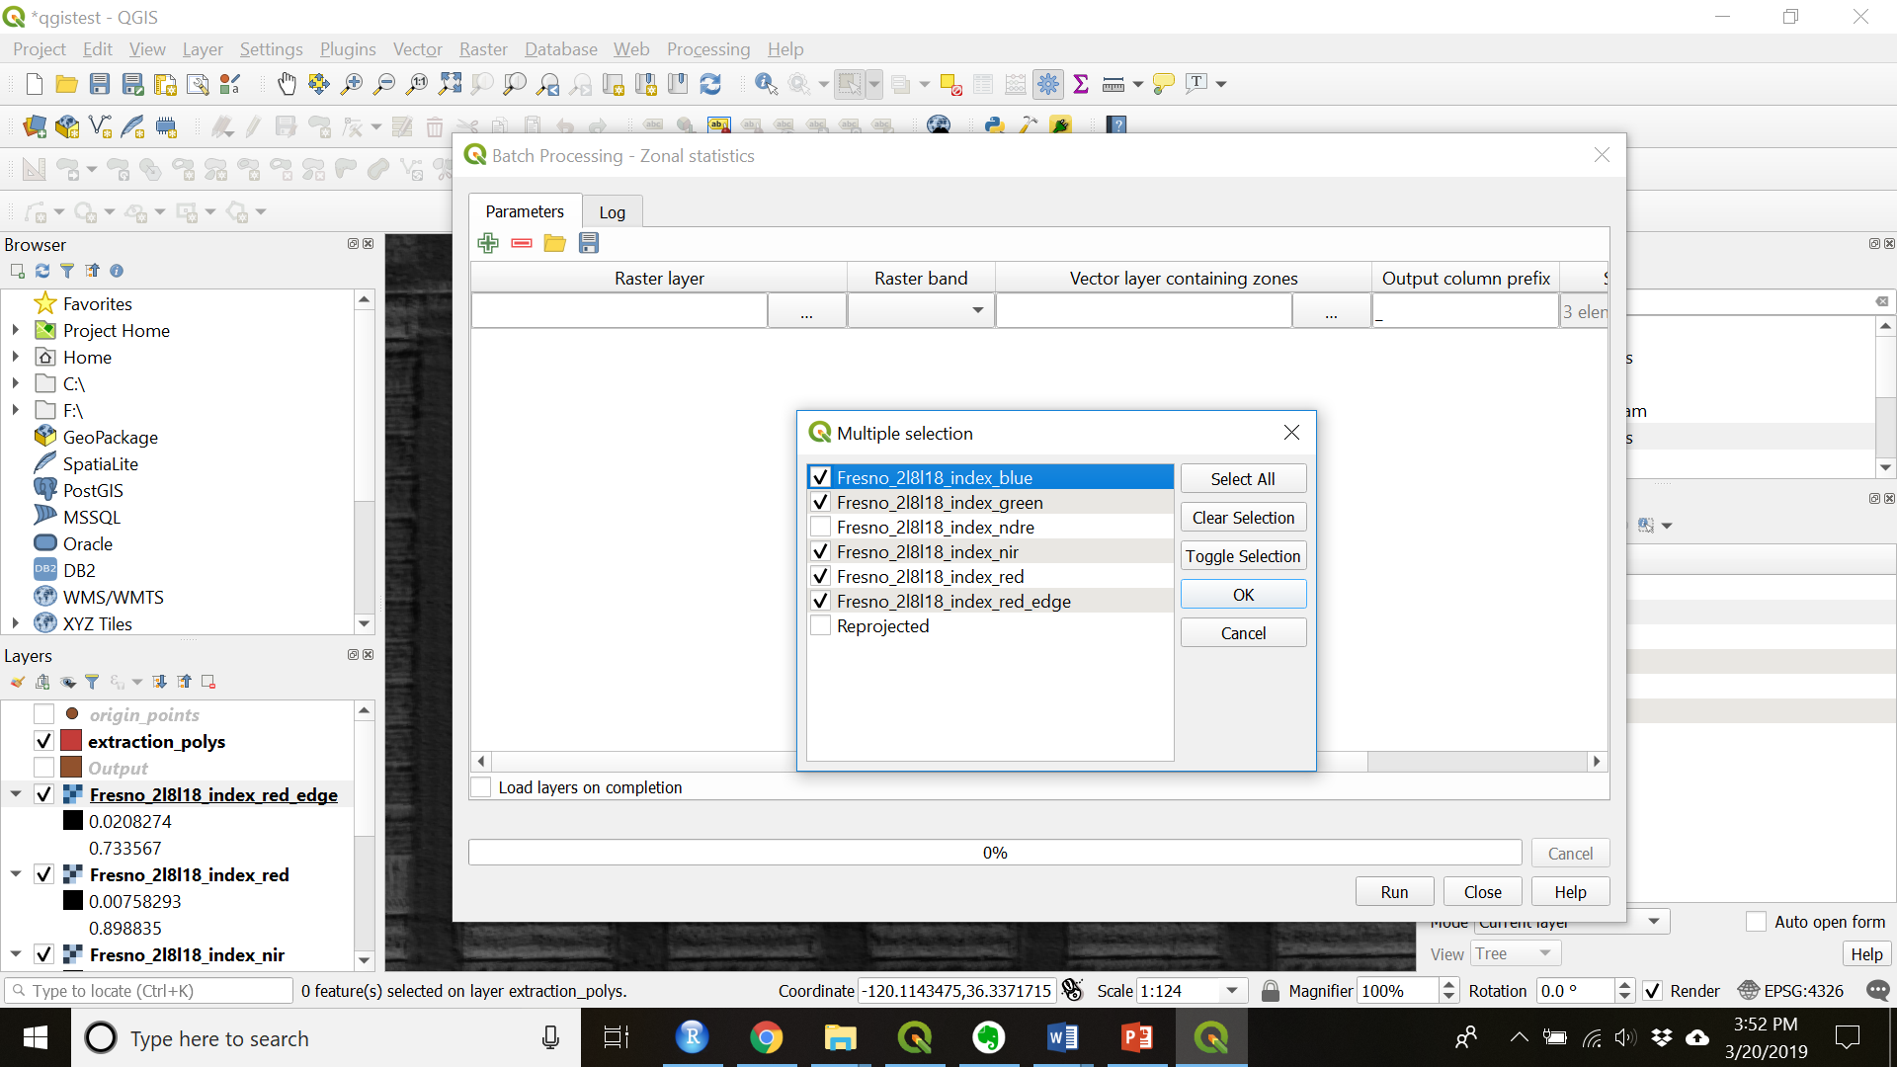

Figure 17. Select the camera bands for extraction

1. Fill out the batch process form (see Figure 18).

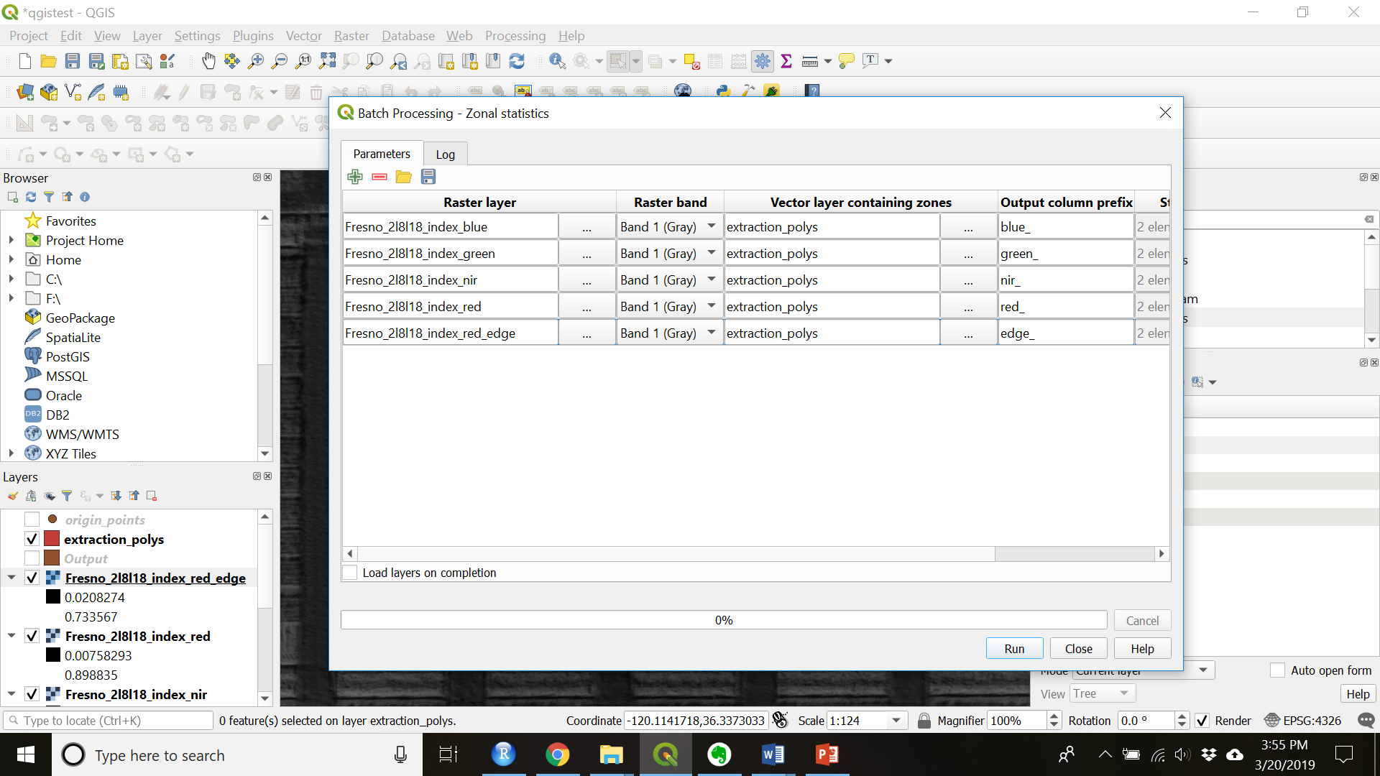

Figure 18. Fill out the batch processing form

1. Click “Run” when you are ready to extract the data
2. Close the window when the algorithm is finished processing.
3. The extraction polygons you created will now have all the extracted data.

# Extracting over several dates

*If you have images from several different dates you have 2 options: 1) You can create a new shapefile and extract data for each date. 2) You can georeference your images so that they overlay each other and then use the same shapefile.*

*In order to georeference you must have static, identifiable objects or characteristics that you can clearly see in the images.*

# Georeferencing:

**With ground control points in Pix4D:**

<https://support.pix4d.com/hc/en-us/articles/202558699-Using-GCPs#gsc.tab=0>

**With tie points in QGIS:**

1. Open QGIS
2. Project > New
3. Add a raster layer of your base image.

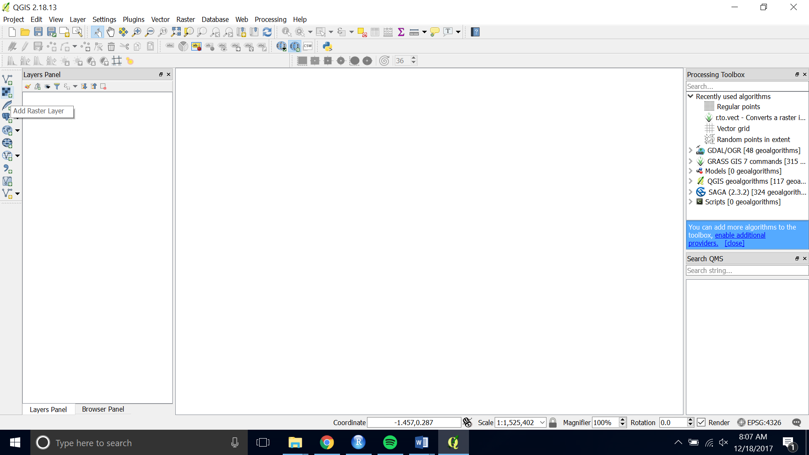

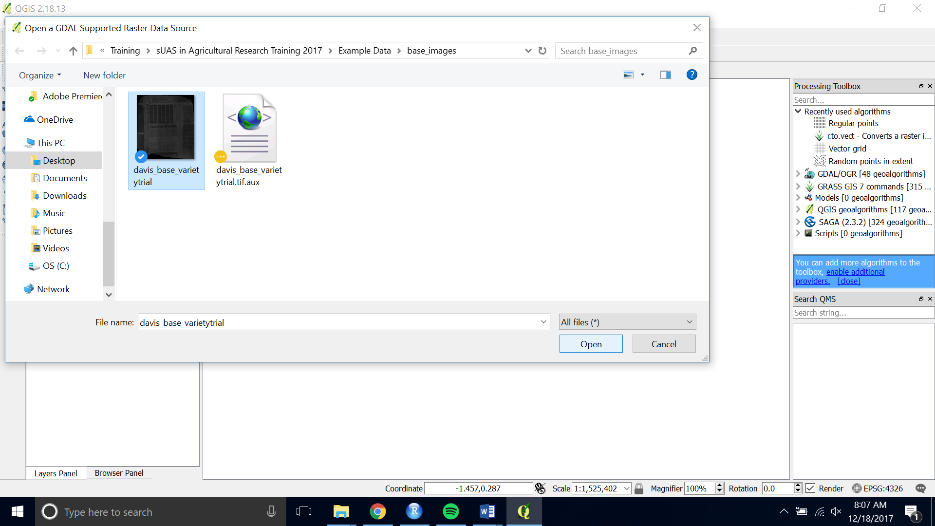

1. Open the Georeferencer.

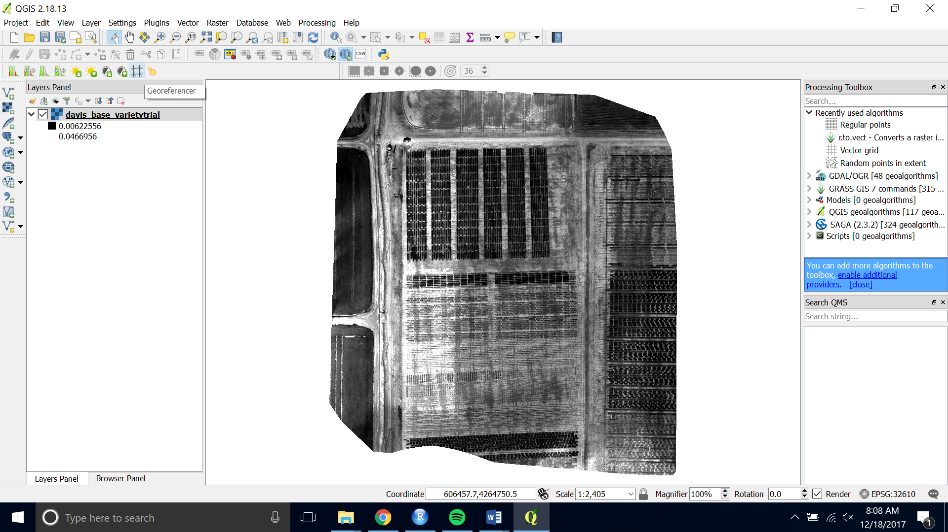

1. Choose the raster you want to Georeference by opening the raster and navigating to the image you want to georeference.

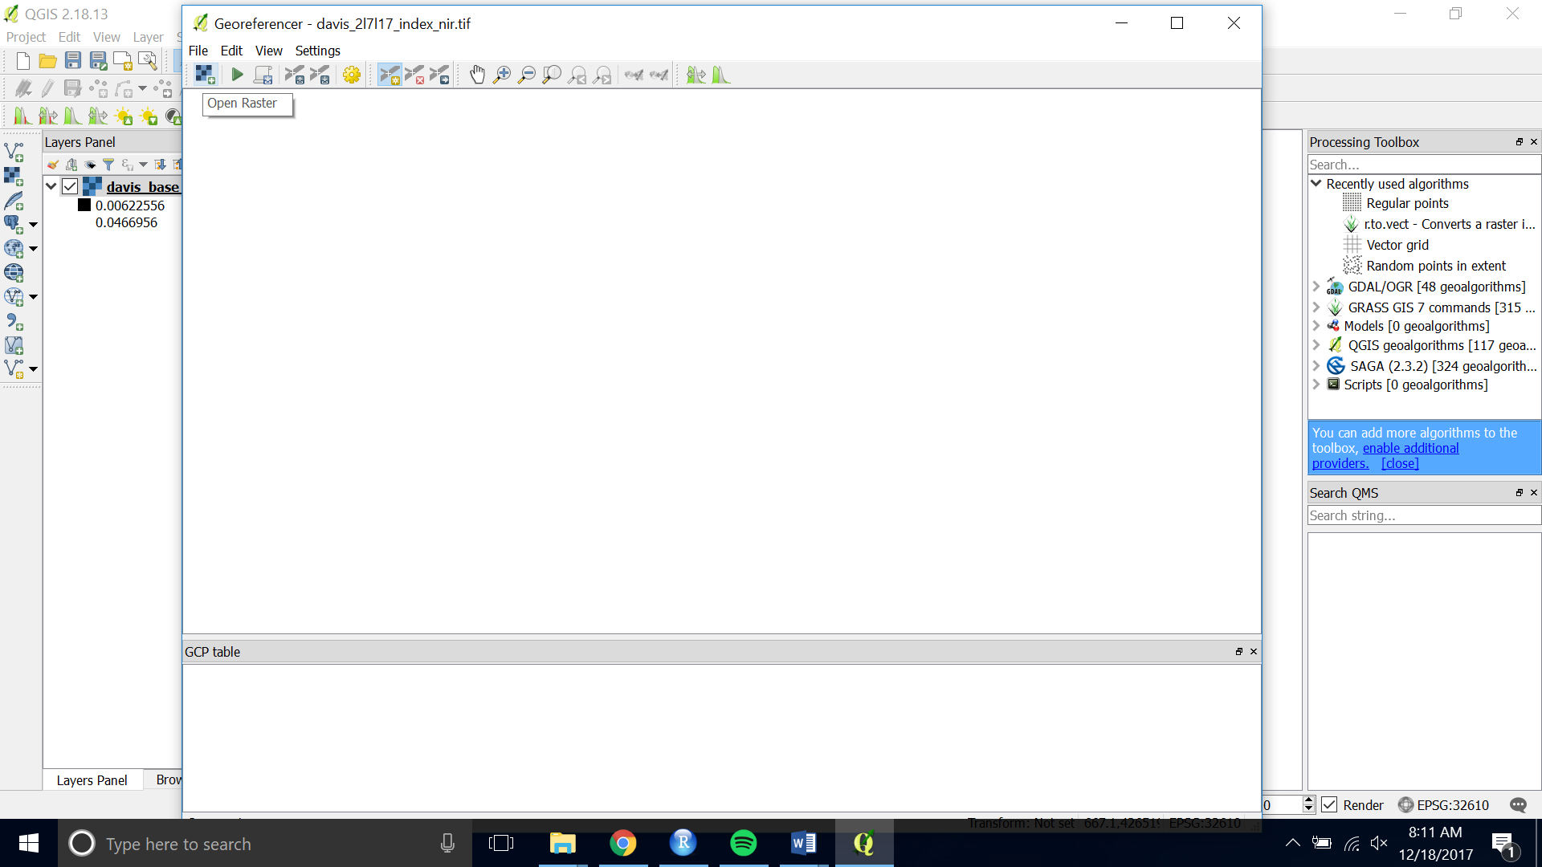

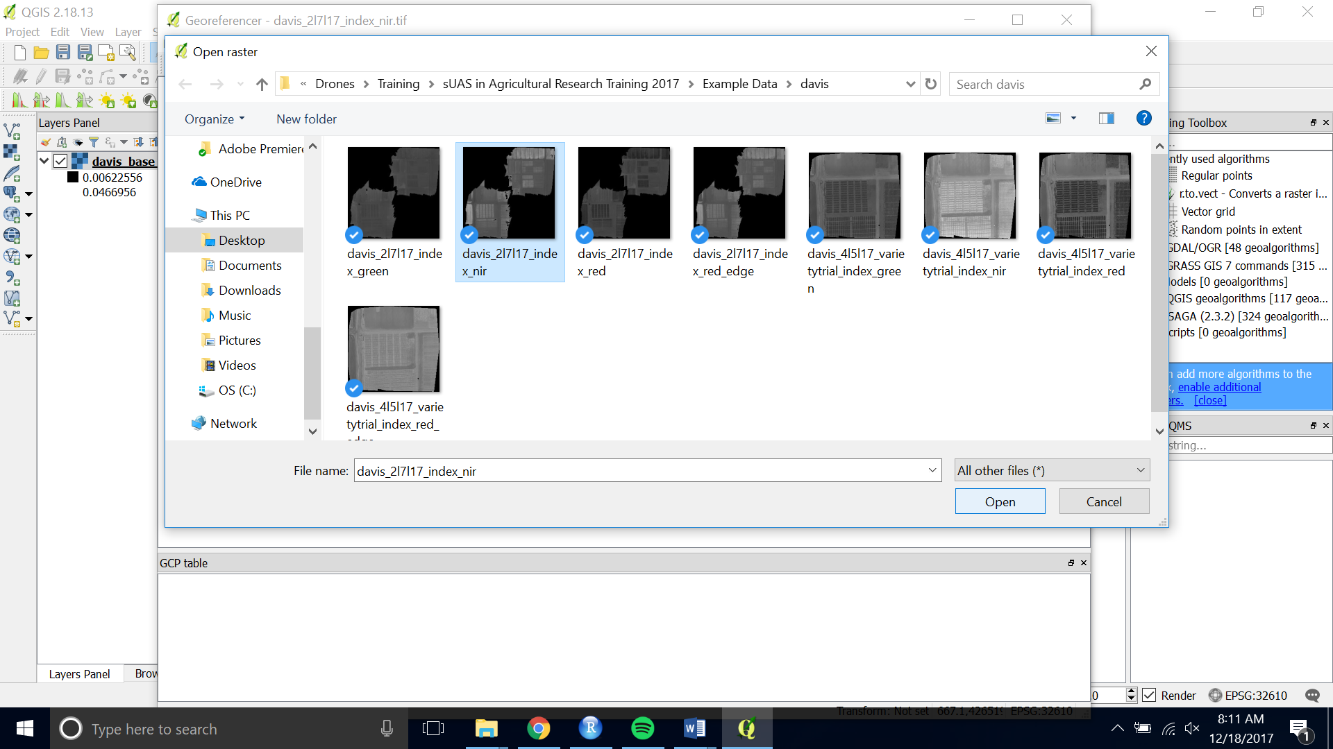

1. Zoom and pan to a place in the image that will be there for the entirety of the season or the time period when you are planning to fly. Using the center of a plot works well.

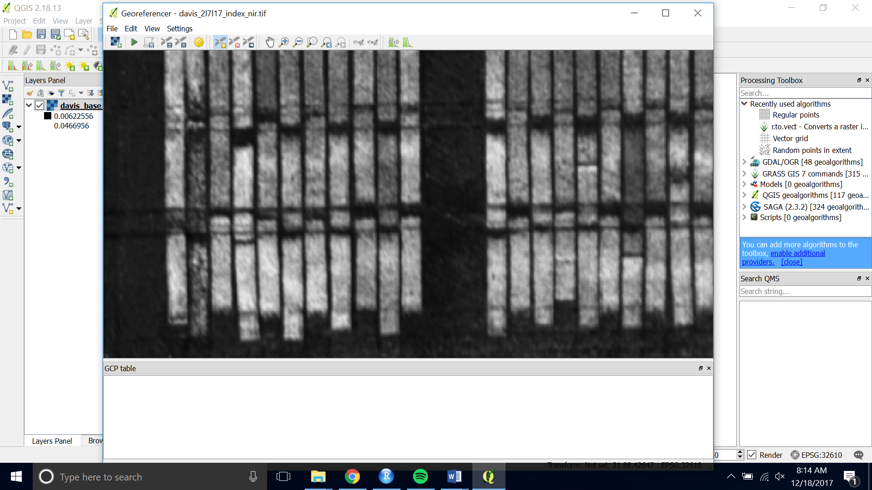

1. Choose the yellow “Add Point” button at the top of the interface.

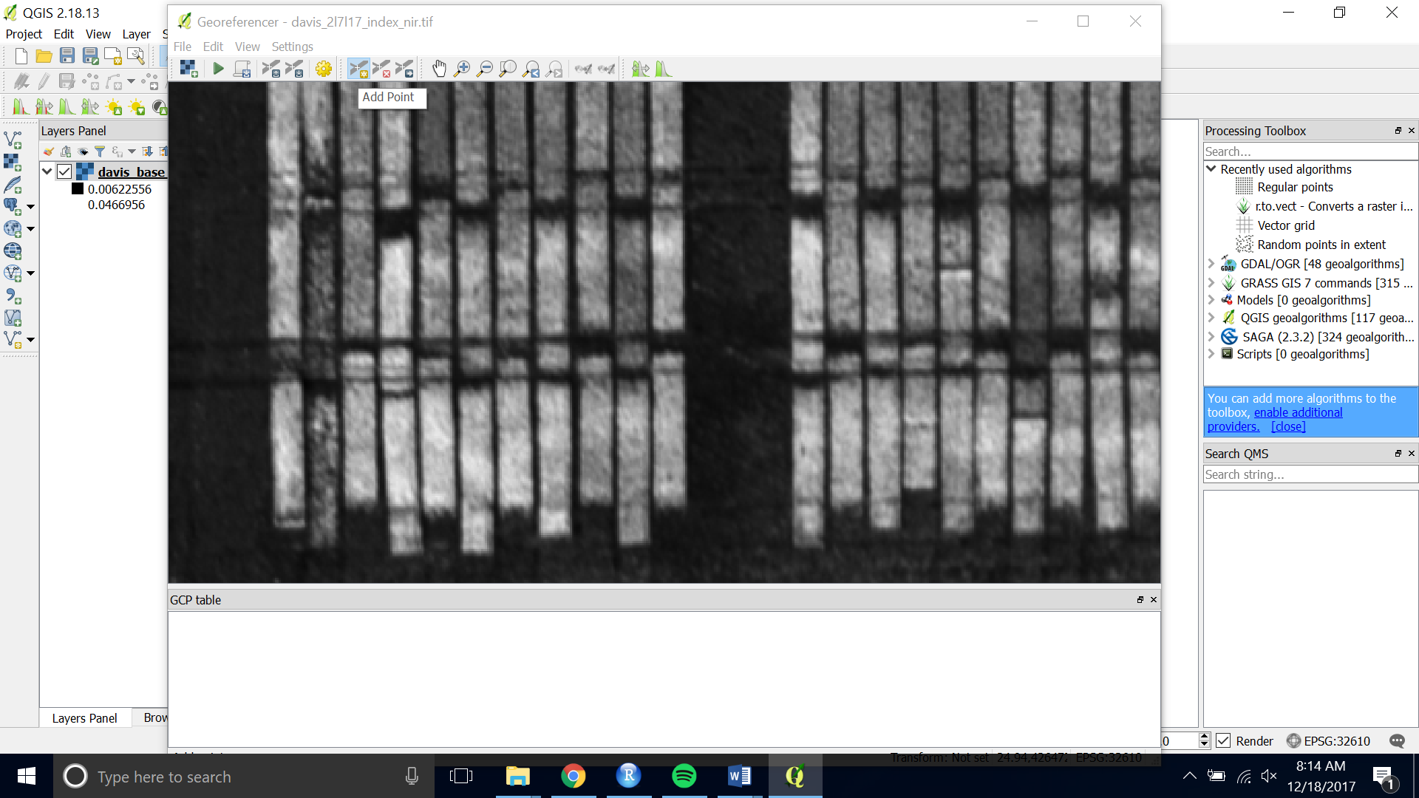

1. Click on the tie point you have chosen. Then choose “From Map Canvas”

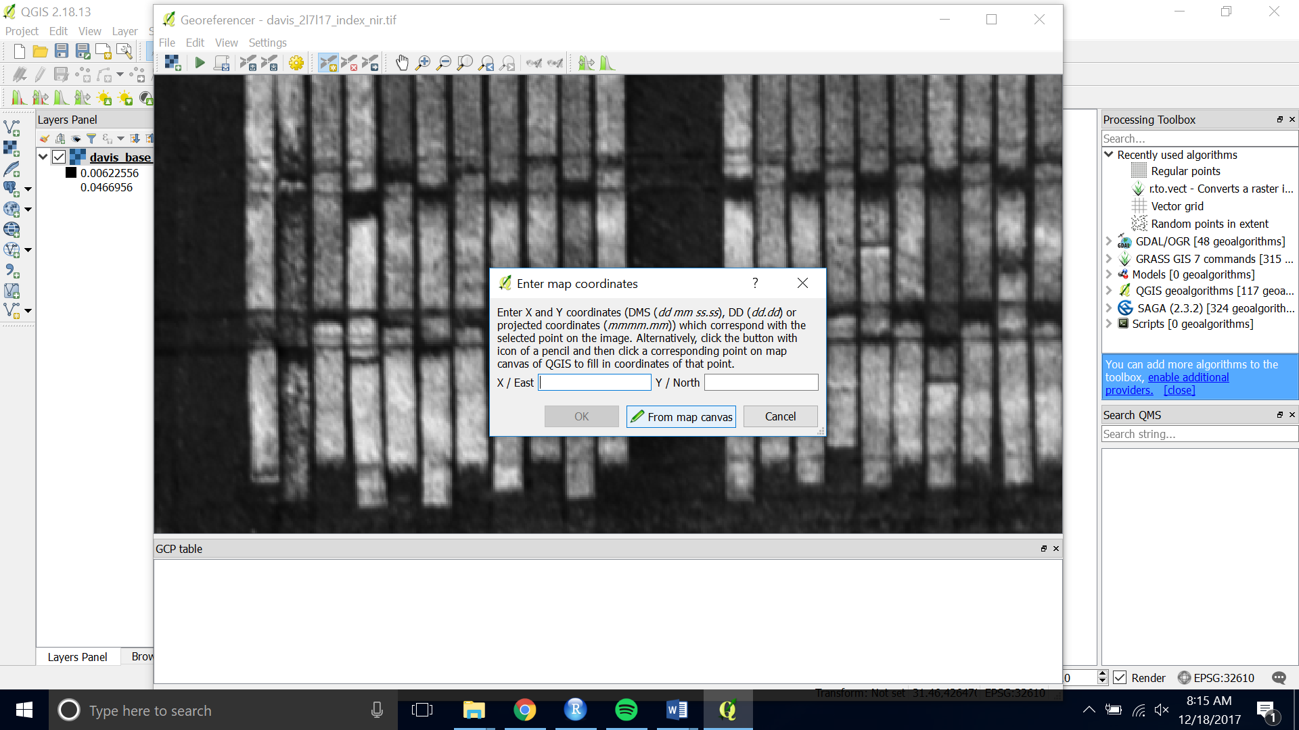

1. Pan, zoom and click on the same point on the base image you loaded onto the map canvas.
2. Then click “OK” to save the point.

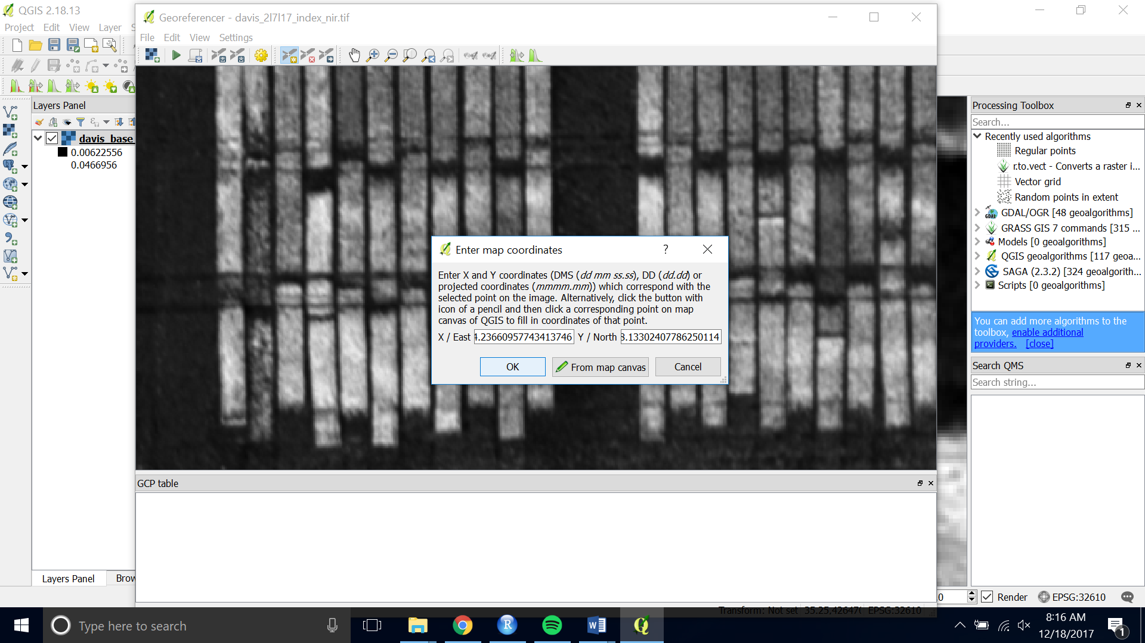

1. Do this for 5 – 10 points around your image.
2. When you are satisfied with the number of ground control points, choose “ Start Georeferncing” (the green play button)

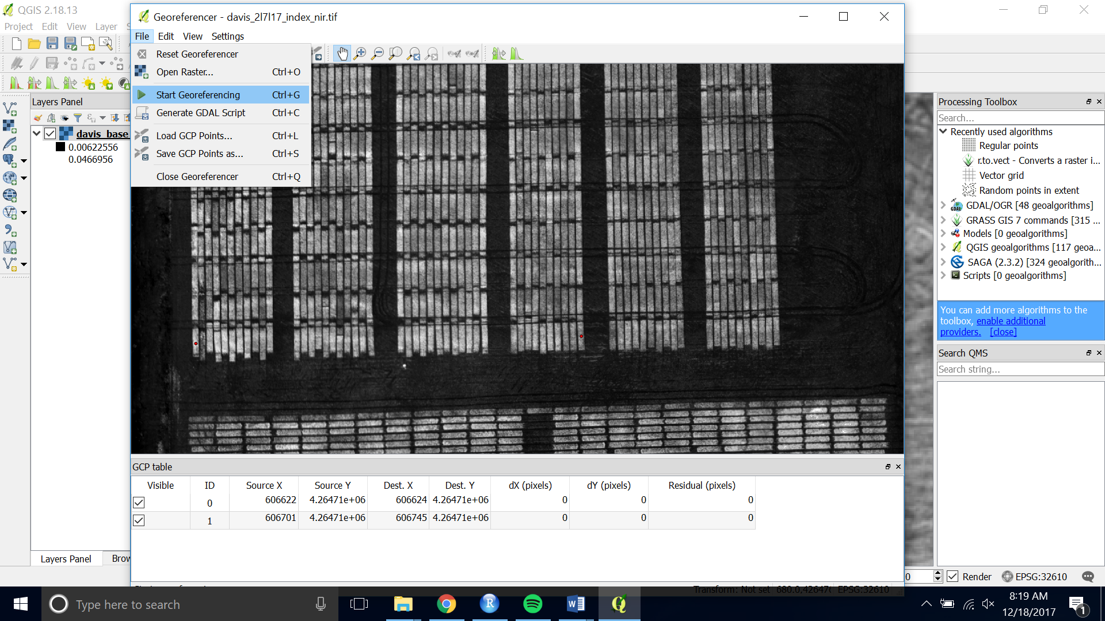

1. If asked for the transformation information you can stick with the default. Check Load in QGIS when done and set the name of your output raster.

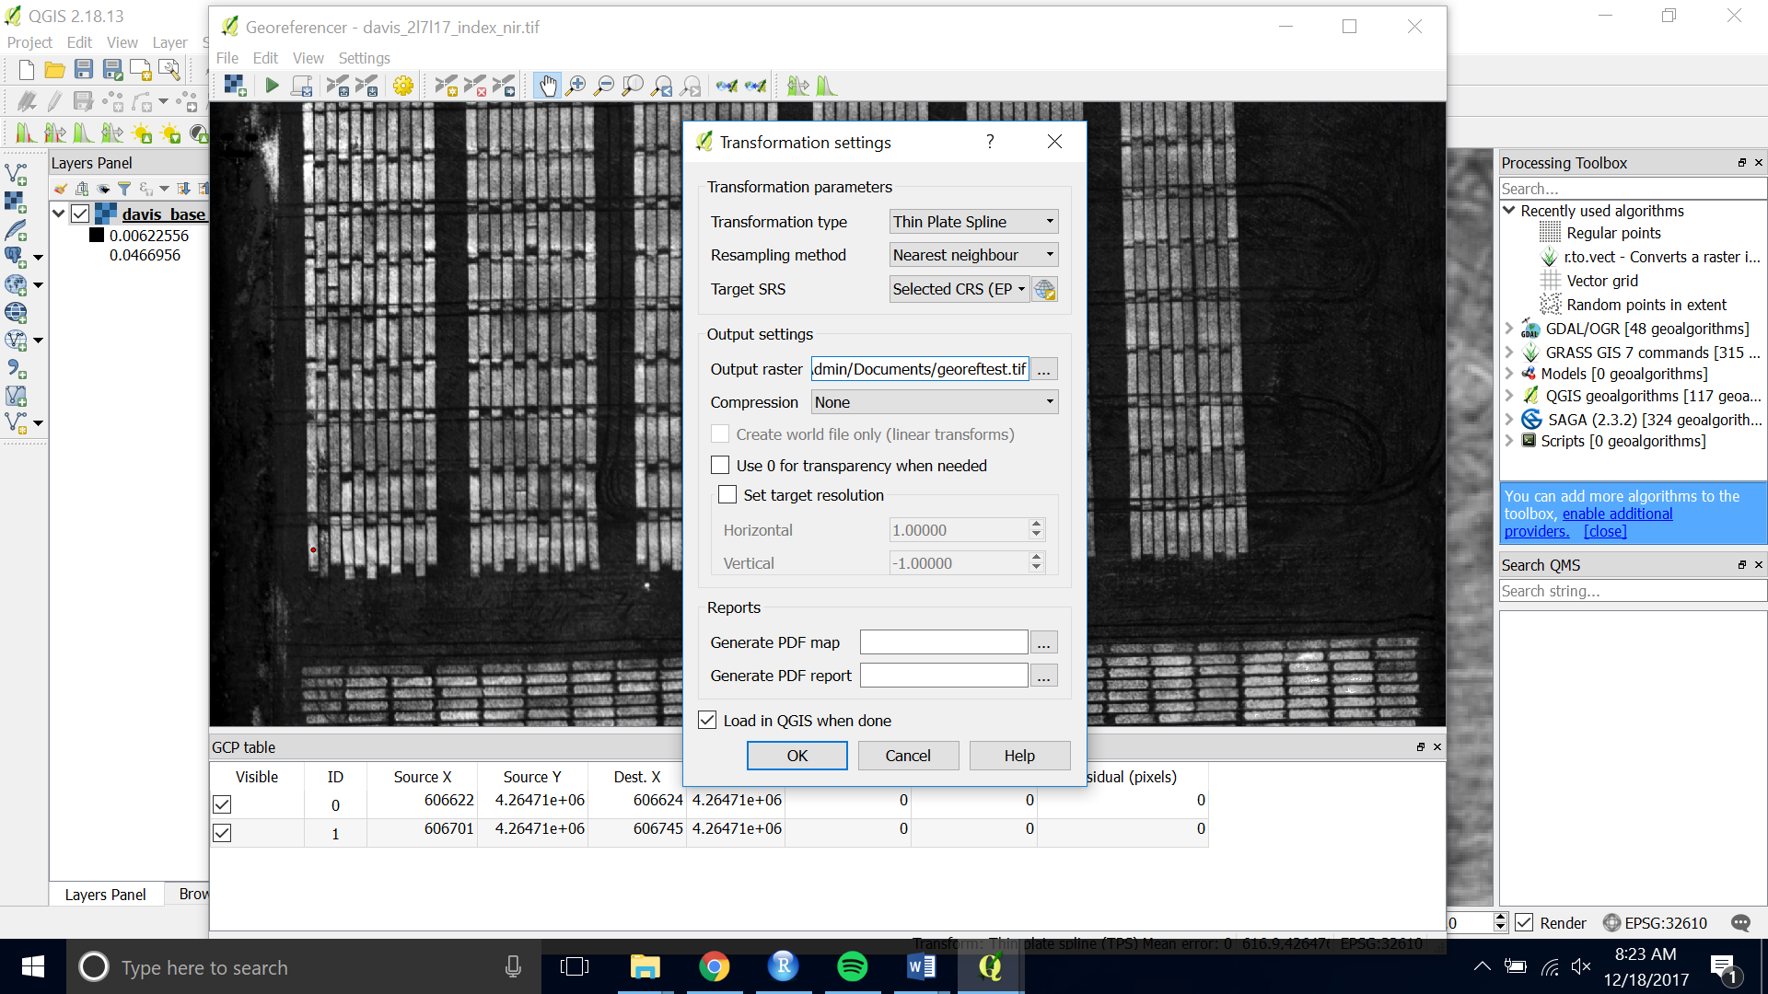

1. Press the green “Start Georeferencing” button again. The georeferenced image will be save and loaded onto the canvas.
2. You can check that it aligns with your shapefile by loading the shapefile onto of it.